

**MSPM’S**

**Deogiri Institute of Engineering and Management Studies, Aurangabad**

**Department of Computer Science and Engineering**

**Report** on

**Child Medical Planner**

**Subject: Seminar**

Submitted By

**Aakanksha Narendra Gaikwad (Roll No: 36002)**

Under the Guidance of

**Prof. Sanjay Kalyankar**

**(**HOD of CSE)

(Deogiri Institute of Engineering and Management Studies)2018-2019



CERTIFICATE

This is to Certify that Mr./Miss Aakanksha Narendra Gaikwad (roll no. 36002) had Successfully Completed his/her Report on date 11/10/2019

**Name of Guide Prof. Sanjay Kalyankar**

**Head of Department of CSE**

**INDEX**

**1 Introduction**

* 1. **Introduction**
  2. **Background on Immunization**
  3. **Vaccinations**
  4. **Objectives**

**2. Literature Survey**

**2.1 Reaching every child with rotavirus vaccine: Report from the 10th African rotavirus symposium held in Bamako, Mali**

**2.2 Dealing with context in logic model development: Reflections from a realist evaluation of a community health worker programme in Nigeria**

**2.3 Child maltreatment prevention readiness in Gulf Cooperation Council (GCC) countries**

**3. Project Design**

**3.1 Defining scope of project**

**3.2 Assumptions**

**3.3 System Design**

**4 Drawbacks**

**5 Future Scope**

**6 Comparison between 3 research papers**

**7 Conclusion**

**1. INTRODUCTION**

**1.1 INTRODUCTION**

Parents want to do everything possible to make sure their children are healthy and protected from preventable diseases. Vaccination is the best way to do that. Vaccination protects the community against vaccine-preventable diseases. Each vaccine plays an important role, so timely vaccination is the best way to protect your child. If children aren’t vaccinated, they can spread disease to other children who are too young to be vaccinated or to people with weakened immune systems, such as transplant recipients and people with cancer. This could result in long-term complications and even death for these vulnerable people.

Over 2 Million children under the age of 5 die every year in India and another 1 Million or more are disabled for life. A major cause is that parents often forget to vaccinate the child on time, as most parents in India do not maintain a vaccination calendar for their child in a disciplined manner. Other reasons are-

- Parents' misplaced priorities

- Low awareness

- Busy lifestyles

- Forgetfulness

- Social and cultural causes

Child medical planner website offers parents access to comprehensive information on immunization as well as the easy-to-use free tools designed to help you save the date to vaccinate. This website provides different facilities like having communication with expert Doctors. We can ask questions to them by email. Vaccination table provided by this website contains all vaccinations which are important for the children. This is the website which save the Date to Vaccinate. A free reminder with Email or SMS helps parents to ensure that their children are fully immunized on time against vaccine-preventable diseases.

Timely vaccination is the best way to keep your child protected from serious vaccine-preventable diseases. You can make an appointment with your doctor by creating an account on Child Medical Planner to help you save the date to vaccinate.

**1.2 BACKGROUND ON IMMUNIZATION**

The issue of immunization financing in developing and transitional countries has become more critical in recent years as some donors have reduced their funding for immunization programmers; as other health priorities, such as HIV/AIDS, compete for limited health funding; and as countries try to increase coverage, to improve immunization safety and to add new, more expensive vaccines such as hepatitis B (HepB) and *Haemophilusinfluenzae* type b (Hib) vaccines to their national immunization programmers. The immunization financing issue is set to become even more important when vaccines currently in the pipeline, such as rotavirus, *Streptococcus pneumonia* (pneumococcus) and other new vaccines, hit the market.

The following sub-sections introduce the main topics of immunization financing, which include immunization costs and cost-effectiveness, financing of immunization programmers, health sector reform, international mechanisms to facilitate immunization financing, and vaccine market.

**1.2.1. Costs of immunization**

The early cost studies from the 1980s showed that costs per fully immunized child varied widely, depending on the delivery strategy used (fixed facilities, mobile services or mass campaigns), the local costs of personnel, and vaccine procurement and distribution. One generally accepted average cost for fixed facilities in low-income countries was US$ 15 per fully immunized child for the traditional antigens of the Expanded Programmed on Immunization (EPI)—BCG (BacilleCalmette-Guérin), diphtheria–tetanus–peruses (DTP), polio and measles vaccines.

**1.2.2. Cost-effectiveness of immunization policies**

Immunization policies compete with other public health interventions for limited budgets both at the national and global level. Within immunization budgets themselves, resource allocation decisions have to be made between different policies and options in terms of expanding coverage or adding new antigens to immunization schedules. Therefore, estimates of cost-effectiveness are essential information for policy makers wishing to allocate resources efficiently. Cost benefit and cost-effectiveness studies generally estimate at what cost public health goals can be reached. Cost-effectiveness studies express results in terms of dollars per disability-adjusted life year (DALY) gained, while in cost–benefit analyses health gains are expressed in monetary terms.

**1.2.3. Financing of vaccines and immunization programmers**

Developing countries have traditionally relied, at least in part, on donor funding to finance their immunization services. This funding has historically been relatively easy to obtain as donors saw immunization as a cost-effective health intervention and more recently as a way to alleviate poverty. However, useful this support is, it does not necessarily encourage countries to increase domestic funding. The PHR review7 conducted in 1998 found that more and more countries were financing at least a portion of their vaccine costs and many now have immunization or vaccine line items in their government budgets. In the PHR e-mail survey sample of 78 countries, more than one-third (36%) reported that they financed 100% of their vaccine supply. As expected, there were large regional variations in the level of self-reliance in vaccine financing—while 18 of the countries surveyed in the Latin American and Caribbean (LAC) region (72%) reported that they were self-reliant in vaccine financing, only three countries from the sub-Saharan Africa sample (11.5%) were. Three-quarters of the overall sample of countries reported having a specific immunization programme or vaccine budgetary line item.

1.3 VACCINATIONS FOR INFANTS AND CHILDREN, AGE 0**–**10 YEARS

Table 1: Vaccination for children

|  |  |
| --- | --- |
| Vaccine | Is your child up to date? |
| **Diphtheria, tetanus, and whooping cough**  (peruses; DTaP) | Your child needs 5 doses of DTaP vaccine. The first dose is given at 2 months, the second at 4 months, the third at 6 months, the fourth at 15–18 months, and the fifth at 4–6 years. |
| ***Haemophilusinfluenzae*type b** (Hib) | Your child needs 3–4 doses of Hib vaccine, depending on the brand of vaccine. The first dose is given at 2 months, the second at 4 months, the third at 6 months (if needed), and the last at 12–15 months. |
| **Chickenpox**  (varicella; Var) | Your child needs 2 doses of chickenpox vaccine. The first dose is given at 12–15 months and the second at 4–6 years. |
| **Hepatitis A**  (HepA) | Your child needs 2 doses of hepatitis A vaccine. The first dose is given at age 1 year and the second 6–12 months later. |
| **Hepatitis B**  (HepB) | Your child needs 3–4 doses of hepatitis B vaccine, depending on the brand of vaccine. The first dose is given at birth, the second at 1–2 months, the third at 4 months (if needed), and the last at 6–18 months. |
| **Influenza**  (Flu) | Everyone age 6 months and older needs influenza vaccination every fall or winter and for the rest of their lives. Some children younger than age 9 years need 2 doses. Ask your child’s healthcare provider if your child needs more than 1 dose. |
| **Measles, mumps, rubella** (MMR) | Your child needs 2 doses of MMR vaccine. The first dose is given at 12–15 months and the second at 4–6 years. |

**1.4 OBJECTIVES**

Project Objectives are as follow:

* To create a website for those parents who often forget to vaccinate their child on time.
* As most parents in India do not maintain a vaccination calendar for their child in a disciplined manner so they can be alert by the SMS or email sent through this website.
* Display the information of all vaccinations needed for the child upto 18 years.
* This website provides the specialist doctors information along with their hospital name, hospital address, email address, mobile number and their own website.
* Using this doctor’s information parents can communicates with the doctors through their email address.

**2. LITERATURE SURVEY**

**2.11 Reaching every child with rotavirus vaccine: Report from the 10th African rotavirus symposium held in Bamako, Mali**

I have researched a research paper naming Reaching every child with rotavirus vaccine: Report from the 10th African rotavirus symposium held in Bamako, Mali. The authors of this research paper are Samba O. Sow a, A. Duncan Steele b, Jason M. Mwenda c, George E. Armah d, Kathleen M. Neuzil. This research paper is having domain Vaccine. This research paper was published at 29 August 2017.

**Introduction**

Preventing rotavirus infection through vaccination is a critical intervention to reduce morbidity and mortality in young children, particularly in settings without accessible or affordable health care. The African Rotavirus Symposium is a gathering of rotavirus experts that occurs every one to two years and provides a unique venue to discuss the latest research findings and global recommendations, and to share monitoring, surveillance, and vaccine introduction data from across Africa and the globe.

This report serves as the proceedings for the symposium. Due to the accelerated vaccine introduction in Africa and the rapid advances in the field, the 9th African Rotavirus Symposium was held in Maputo, Mozambique in December 2015, one year after the 8th African Rotavirus Symposium . The symposium focused on assessing the role of the regional rotavirus surveillance network in defining rotavirus epidemiology in the pre-vaccine era, and the on-going efforts to assess the impact of vaccines and to monitor adverse events.

**Proceedings of meeting**

As of May 2016, 33 African countries (29 in the African Region and 4 in the Eastern Mediterranean Region) have rotavirus vaccine in their EPI, while 21 have yet to introduce the vaccine. Dr. Steele outlined several potential approaches to achieve the goal of reaching every child with rotavirus vaccines. These included enhancing supply by supporting existing and new suppliers, ensuring new rotavirus vaccines have an acceptable presentation, pursuing next generation rotavirus vaccines to improve efficacy, and strengthening the routine immunization system.

**Disease Burden in Africa: rotavirus and beyond**

Based on a literature review and data from the global rotavirus surveillance network coordinated by WHO, Dr. Tate reported the proportion of diarrheal deaths due to rotavirus is declining, but there are disparities related to vaccine access. In 2013, 34 percent of the population in developed countries lived in a post-rotavirus vaccine introduction country compared to less than 10 percent of the population in all other countries. An estimated average of 215,000 (range: 197,000 to 233,000) rotavirus deaths occurred among children less than 5 years of age in 2013. Of these remaining rotavirus deaths, 56 percent are estimated to occur in sub-Saharan Africa.

**Rotavirus vaccine effectiveness and impact**

Dr. Bavin Jani, WHO, reported data from Tanzania where Rotarix was introduced in late 2012. After vaccine introduction, confirmed rotavirus cases decreased in infants less than 1 year of age by 50 and 70 percent respectfully, in 2014 and 2015.

**Advances in rotavirus science: informing public health**

The lower immunogenicity of rotavirus vaccines in poor countries is not completely understood. Speakers explored several possibilities for this phenomenon and presented data on the relationship between immunization schedule and dose, gut biome, maternal factors, strain diversity, immunogenicity, whole genome sequencing (WGS) and alternative schedules and doses. Dr. George Armah, Noguchi Memorial Institute, Ghana, explained how differences in the gut microbiome may impact vaccine efficacy.

The high enteropathogenic burden from multiple coinfections changes the intestinal microbiota, which can alter immune response to oral enteric vaccines, like rotavirus. Rotavirus vaccine response negatively correlated with increased bacilli, in particular Streptococcus bovis.

**Summary**

Rotavirus is the most common cause of severe dehydrating diarrhea among young children in Africa. The past several years have seen unprecedented introduction of rotavirus vaccines into African countries. At this symposium, many countries reported on the impact of rotavirus vaccines in reducing diarrheal morbidity. Intussusception surveillance in Africa is in the early stages. The research agenda is robust. Dr. Jason Mwenda, WHO/AFRO, reaffirmed the importance of the African Rotavirus Surveillance Network to estimate the burden of rotavirus diarrhea in children under five, document rotavirus strains in the region, support awareness and regional advocacy efforts for vaccine introduction, conduct post-marketing surveillance, and evaluate the impact and effectiveness of vaccines.

**2.12 Dealing with context in logic model development: Reflections from a realist evaluation of a community health worker programme in Nigeria**

I have researched a research paper naming Dealing with context in logic model development: Reflections from a realist evaluation of a community health worker programme in Nigeria. The authors of this research paper are Bassey Ebensoa,⁎, Ana Manzanoc, Benjamin Uzochukwub, Enyi Etiabab, Reinhard Hussa, Tim Ensora, James Newella, Obinna Onwujekweb, Nkoli Ezumahb, Joe Hicksa, Tolib Mirzoeva. This research paper is having domain Evaluation and Program Planning. This research paper was published at 07 December 2018.

**Background**

In the realist evaluation (RE) approach, which is a form of theorydriven evaluation, evaluators do not ask ‘what works?’, ‘does this work?’ or ‘did this work this time (Pawson & Tilley, 1997)?’ Rather, they seek to establish “how and why programmes work (or do not work), for whom they work, to what extent, in which settings and for how long?’(Westhorp, 2014, Pg4). In recognition of the influence of context on programme implementation and its outcomes, Pawson and Sridharan (2010) urged scholars to model, in diagrammatic form, the process through which programmes achieve their ends.

In response to Pawson and Sridharan’s call (2010), this paper shares how we developed our LM within an ongoing RE of a community health workers programme in Nigeria, including how we incorporated context into the LM. An overall aim of the RE is to assess the extent to which and under what circumstances, the CHW programme promotes equitable access to quality maternity services in Nigeria and improves maternal and child health (MCH). A secondary aim is to assess the sustainability of achieved outcomes and the effects of ongoing advocacy efforts to entrench MCH in the national political agenda.

**Logic models**

Logic models are tools for planning, describing, managing, communicating, and evaluating a programme or intervention (CDC, 2013; Millar, Simeone, & Carnevale, 2001; Naimoli, Frymus, Wuliji, Franco, & Newsome, 2014). The LM offers a simplified visual representation of the relationship between various components of a programme (Kaplan & Garette, 2005; Renger et al., 2015), and may include assumptions that underlie expectations that the programme will work under certain environmental conditions to solve a particular social problem (Knowlton & Phillips, 2012; McLaughlin & Jordan, 2015). Logic models vary in their complexity and take many different forms, including flowcharts, tables, pictures, and diagrams, and can include different components (Funnell & Rogers, 2011; Newton, Poon, Nunes, & Stone, 2013; Petersen, Taylor, & Peikes, 2013).

**Methods**

We now explain how we created the LM through a multi-stage process, using data from diverse sources.

i)Logic model training meetings:

Research teams from the University of Leeds and the University of Nigeria met in the first

two weeks of July 2015 for a logic modelling training. The training used published literature on theory-driven, realist evaluation principles and logic modelling; and focused on how mapping programme inputs, activities and outcomes can help establish initial hypotheses for tentative relevant Contexts, Mechanisms, Outcomes and CMO configurations

.

ii) Documentary review:

Training meetings were followed by review of key documents, to extract relevant information about programme components from the documents. Documents were reviewed collaboratively by researchers in both institutions, who then shared their summaries with programme implementers and policymakers in Nigeria.

iii) Email discussions and teleconferences:

The draft LM created during steps i and ii was shared with policy makers and implementers to establish their understanding of the model. Programme implementers that contributed to the LM were: a) the national SURE-P programme manager; and b) oversight and validation (O&V) officers charged with monitoring SURE-P MCH activities at health facility level. The O&V officers produced monthly NHMIS reports on human resources; drugs and supplies; facilities upgrade; and expenditure by health facilities.

iv) Technical workshop:

Building on the feedback from stakeholder consultations, we conducted a 3-day face to face technical workshop in September 2015, involving 10 researchers from universities of Leeds and Nigeria. The workshop was used to untangle relationships between programme elements, clarify contextual factors that affected the implementation and results of CHW programme, and subsequently develop initial working theories (IWTs) about how, why and in what circumstances the theories may work.

**Logic model features**

Our experience of creating a LM for the CHW programme showed that different versions of logic models may be needed during the development process, at different evaluation stages and across projects. Creating a LM is not an end in itself. By displaying inter-relations among programme components, creating a LM is an essential step in the task of developing an empirically-based and theoretically-grounded model of complex relations between a programme, its outcomes and its broader context. Involving policy makers and implementers in creating the LM facilitated better understanding of the logic that connected the CHW programme to its outcomes (Ling et al., 2012), thus minimizing the risk that external researchers will have only a limited knowledge of the local context.

**Conclusion**

Multi-intervention health programmes such as the CHW programme in Nigeria are complex, dynamic and always evolve in response to local contexts, service user preferences and other events that can affect the implementation and impact of the interventions. As complex intervention programmes are difficult to evaluate by traditional experimental designs, we applied a programme logic model as part of an ongoing realist evaluation project, to help depict the relationships among the inputs, activities, outputs and outcomes of the CHW programme. We also used logic model development as a tool for identifying initial hypotheses for relevant tentative contexts, mechanisms and outcomes and CMO configurations of how the programme will promote equitable access to quality maternity services and improved health outcomes.

**2.13 Child maltreatment prevention readiness in Gulf Cooperation Council**

**(GCC) countries**

I have researched a research paper naming Child maltreatment prevention readiness in Gulf Cooperation Council (GCC) countries.The authors of this research paper are Majid Al Eissa a, b, c, *, Hassan N. Saleheen a, b, Maha Almuneef a, c, Muna Al Saadoon d, Mona Alkhawari e, Aisha Almidfa f, Fadheela Almahroos ga. This research paper is having domain International Journal of Pediatrics and

Adolescent Medicine. This research paper was published at 17 July 2019.

**Introduction**

Child maltreatment (CM) is a global public health problem that, as our knowledge of the prevalence of abuse has increased, has received greater attention over the past five decades [1]. Children exposed to emotional, physical, or sexual abuse and other adverse conditions are at much greater risk of various negative health outcomes in adulthood, including poor self-rated health, chronic disease, functional limitations, premature mortality, and poor mental health.

**Materials and methods**

1. Participants

This cross-sectional study was conducted in 2016 with key informants (n ¼ 244) from the GCC countries. These key informants were individuals with some degree of influence and decisionmaking power over CMP, including policymakers, program planners, commissioners and implementers, high-level practitioners, and high-level civil servants with a strong interest in CM.

2.Training the site investigators

The NFSP, which is based in KSA, was the lead site for this study. The research team comprised site investigators and a group of researchers. The site investigators were mainly senior pediatricians and professionals from governmental agencies working in the field of child health.

3.Procedure

After receiving the standardized training, the site investigators contacted potential participants by telephone and introduced them to the study. Participants received an explanation in terms of the

nature of the study. Face-to-face interviews were conducted with all participants, usually at their workplace. Before beginning the interview, the data collectors presented endorsement letters to the participants that described the goals of the study and outlined its anonymous nature.

4.Measures

The Readiness Assessment for the Prevention of Child Maltreatment (RAP-CM) was developed by the WHO in five countries (Brazil, The Former Yugoslav Republic of Macedonia, Malaysia,

Saudi Arabia, and South Africa) through a five-stage process [15e21]. The RAP-CM is based on a model of readiness for CMP with 10 dimensions, each containing several items: (1) attitudes

toward CMP; (2) knowledge of CMP; (3) scientific data on CMP; (4) current program implementation and evaluation; (5) legislation, mandates, and policies; (6) will to address the problem; (7) institutional links and resources; (8) material resources; (9)

human and technical resources; and (10) informal social resources

5.Ethics

Candidates determined to be eligible to participate were fully informed about the study, their right to refuse or withdraw, and all procedures put in place to ensure the privacy of the interviews. They were asked (individually and separately) to review an informed consent statement before agreeing to participate in the study. Prior to providing their consent, they were again told the nature of the study and given more information on the types of question that they would be asked. Subsequently, the participants either signed or initialed the informed consent form.

**Conclusion:**

GCC countries have to implement large-scale evidence-based CMP programs. Strengthening their material, human, and technical resources, and improving the quality

of scientific data are required to improve each country's

readiness. to implement such programs. Particularly, we advise that public education campaigns be launched in order to raise awareness of the seriousness of CM and its prevention. National

surveys should also be carried out to assess the magnitude of CM in the GCC countries. Finally, specifically tailored and evidencebased CMP programs should be implemented at the national level towards different target groups, including children, caregivers at risk, and the general population.

**3. PROJECT DESIGN**

**3.1 DEFINING THE SCOPE OF THE PROJECT**

The scope of a project is the clear identification of the work that is required to successful complete or deliver a project.

Official information from Child Medical Planner about Scope including contact details, doctor suggestions, automatic reminders, and vaccines detail as the vaccine is compulsory or mandatory.The website has its email id, its face book page, twitter page, and pintrest id for the convenience of the users. The website also contains a Google map that will show you your directions so you can find out the nearest hospital from you.

The scope of the project is very vast if available publically any one can use it over the world. The child medical planner as the important factors are the birth date of child so any one can register with a valid date and can get the benefit of reminder of vaccinations. As the user registered first he needs to add the vaccines he has given to the child after adding the first three vaccines user will get the reminder automatically. Again you can deflect your account or you can make updates in your childes profile.

**3.2 ASSUMPTIONS**

An assumption is a belief of what you assume to be true in the future. You make assumptions based on your knowledge, experience or the information available on hand. These are anticipated events or circumstances that are expected to occur during your project’s life cycle.

Assumptions are supposed to be true but do not necessarily end up being true. Sometimes they may turn out to be false, which can affect your project significantly. They add risks to the project because they may or may not be true.

* You will get recourse required by you.
* People will contact customer service if they have a question or problem
* People will come back
* People know how to buy
* People will know how to find your website
* People know what you sell
* Everything will go as planned
* People know where to click
* People know how to get home
* People know where they are

**3.3 SYSTEM DESIGN**

**3.3.1. Sequence diagram-**

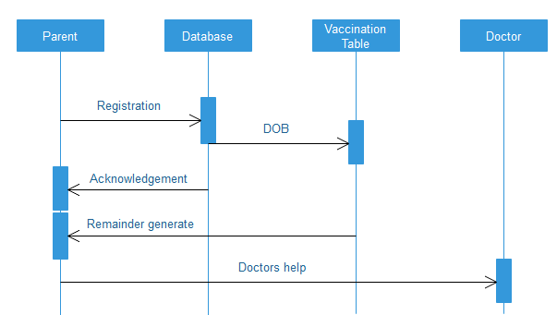**Fig.3.1** Sequence Diagram View

**Description of sequence diagram**

A text format is convenient for writing, but it does not clearly show sender and receiver of each message, especially if there are more than two objects .A sequence diagram shows an participants in an interaction and the sequence of the messages among them. A sequence diagram shows the interaction of the system with its actor to perform all or part of a use case. Each sequence diagram shows a particular behavior sequence of the use case .it is best to show a specific portion of the use case and not attempt to be too general. Although it is possible to show the conditionals within sequence diagram. Usually it is clearer to show a one sequence diagram from each major flow of control.

The above sequence diagram is showing a simple sequence flow of our website. Where the Parents, Vaccination Table, Doctors’ information for further detailing through user, Database are the entities. Parent will be first activated then it registers, data will be stored. Then according to the database and the functions the Vaccination table for the every single child i.e. child profile. Then acknowledgment is given to parent that they have successfully registered. On the basis of Vaccination table the reminder will generate. User can also get the information of doctor.

**3.3.2. Use Case diagram-**

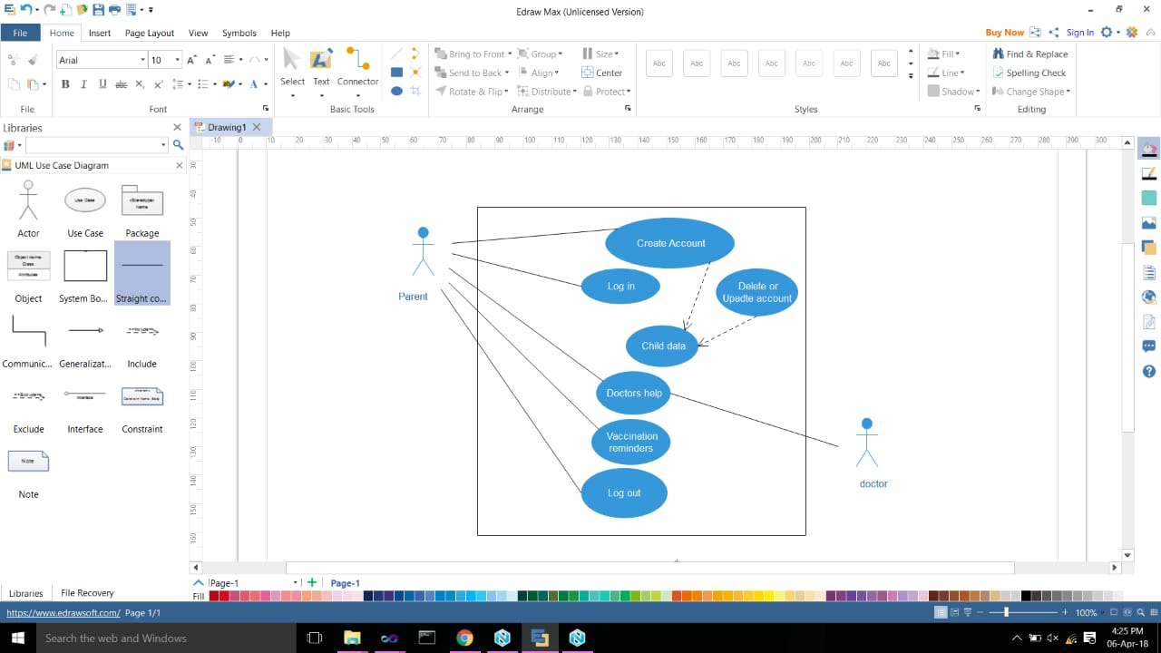

**Fig.3.2.** Use Case View

**-Description of Use case diagram**

Use case indentifies the functionality of a system and organizes it according to the perspective of users. In contrast, traditional requirements lists can include functionality that is vague to users, as well as overlook supporting functionality, such as initialization and termination. use case describes complete transactions and are therefore less likely to omit necessary steps. There is still a place for traditional requirements lists in describing global constraints and other no localized functionality, such as mean time to failure and overall throughput, but you should capture most user interactions with use cases. The main purpose of a system is almost you always found in the use cases, with requirements lists supplying additional implementation constraints. A system involves set of use cases and a set of actors. each use case represents a slice of the functionality the system provides.

In this use-case diagram, the user and doctor are the actors which will perform some activity. if user is new, then he can create account for next process, otherwise, and if user already exists then just he has to enter the log in details like username and the password . User can modify the data as required. He can go back from the website by the logout( ).

**3.3.3. Activity diagram**

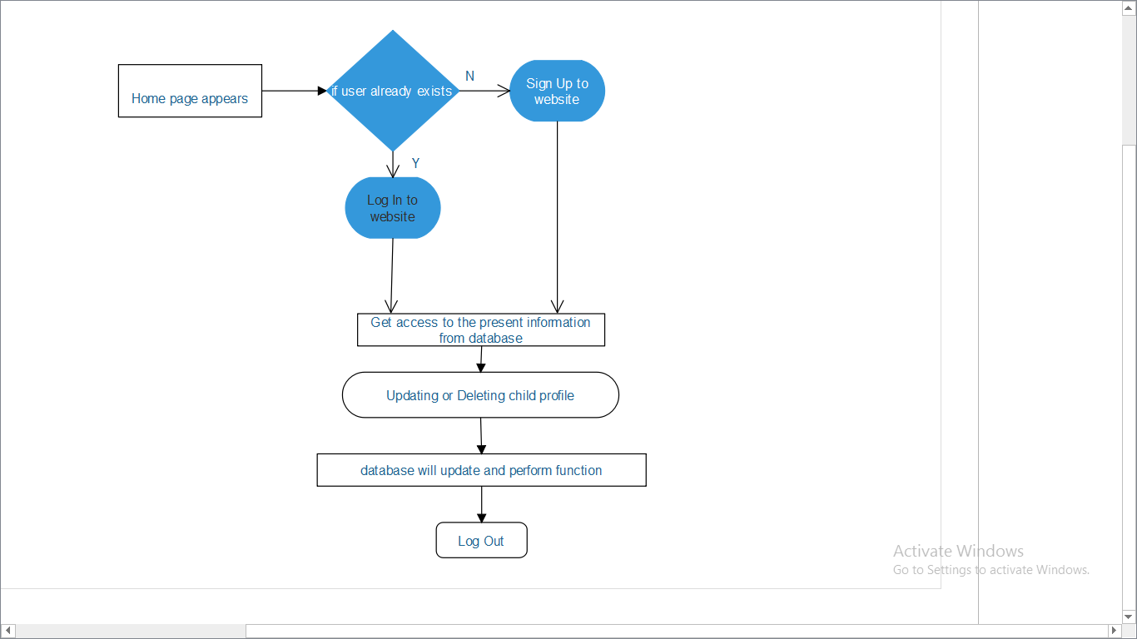

**Fig.3.3** Activity Diagram View

**-Description of Activity diagram**

The steps of activity diagram are operations, specifically activities from the state model. The purpose of an activity diagram is to show the steps within a complex process and the executing consisting among them. some activities run forever until an outside event and interrupts them but most activities eventually complete their work and terminate by themselves the competition of an activity is a competition event and usually indicates that the next activity can be started. An unlabeled arrow from one activity to abort in an activity diagram indicates that the first activity must complete before the second activity can begin an activity may be decomposed into fine activities.

Activity diagram are not only useful for defining the step in a complex process but they can also be used to show the progression of control during execution. An activity token can be placed on an activity symbol to indicate that it is existing.

**3.3.4. State chart diagram**

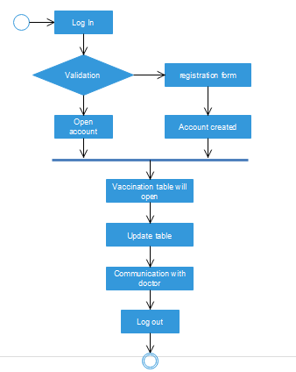

**Fig.3.4** State Chart Diagram View

**-Description of State Diagram**

A state diagram is a graph whose nodes are states and whole directed arcs are transmissions between states A state diagram specifies the state sequences caused by event sequences. State names must be unique within the scope of a state diagram. All objects in class execute the state diagram for that class, which models their common behavior. You can implement state diagrams by direct interruption or by converting the semantics into equivalent programming code .the state models consist of multiple state diagrams, ones state diagram for each class with improvement temporal behavior. The state diagram must much on their interface events and guard conditions.

The individual state diagrams interact by passing events and through the side effects of guard conditions. Some events and guard conditions appear in a single state diagram, other spear in the multiple state diagram for the purpose of coordination. A class with more than one state has important temporal behavior.

**3.3.5. Collaboration diagram-**

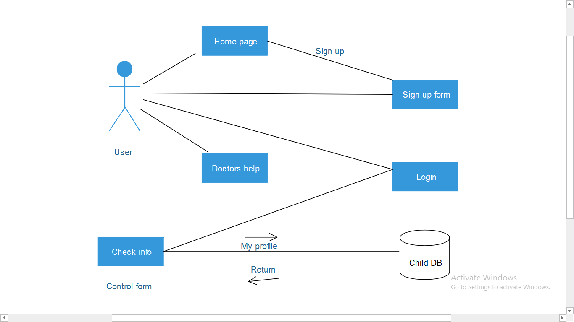

**Fig.3.5** Collaboration Diagram View

**-Description of Collaboration diagram**

Collaboration diagram are useful when to see what association are being affected with dependencies between objects are good for showing for showing association an control flow arrow and join the instances which represent associations. A collaboration diagram is a type of visual presentation that shows how various software objects interact with each within an overall it architecture and how user can benefit from this collaboration.

A collaboration diagram often comes in the form of a visual chart that resembles a flow chart. It can show, at a glance, how a single piece of software complements other parts of a greater system. Generally, the labels on a collaboration diagram are determined by the needs of the user base someone creating this kind of resource may use actual file names, generic phrases representing the function of programs, or even customized icons to show how pieces of a system work together. Customized collaboration diagrams can help business leaders and others to see more about what’s going on within a complex it system and how software interactions work.

**3.3.6. Flowchart of website-**

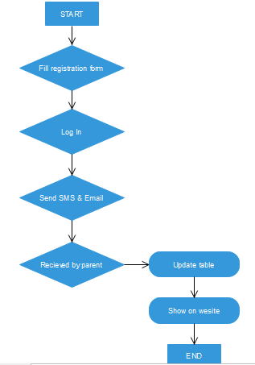

**Fif.3.6** Flow Chart Diagram View

**4. Drawbacks**

**Limitations**

* One user can create only one account.
* The user has to fill in the first three vaccines then only the remainder will generate.
* Every time user has to add the done vaccines.
* It is not possible to re add or reset the vaccines list.
* The remainder will be send through a SMS (offline) but the user first needs the internet to sign up and creating the account.
* User has to manage his/her vaccine list date to date.

**5. Future Scope**

**FUTURE SCOPE**

Our website “Child Medical Planner” will become an application for android in future. As the useful vaccinations are introduced by government for the children and those vaccinations are available all over the specified area. Our website will add it into out vaccination table for users convenience. Because mobile applications will almost certainly represent the future of immunization records and trigger the advent of the next generation of immunization information systems. Increasing fragmentation of immunization delivery will increasingly necessitate individuals to be empowered to track their own immunizations. Mobile applications will facilitate this and by permitting a mechanism for sharing of information between an individual, their healthcare provider and central immunization information repositories enable all 3 to have the same immunization data in real time. Quality and granularity of immunization data will improve with mobile applications, something that will be facilitated by barcode scanning. Mobile adverse event reporting and public health officials addressing vaccine hesitancy through geofenced targeted communication will be possible. Digital immunization passports that are recognized by country border officials as proof of immunization are likely to soon be developed and could address International Health Regulation requirements for proof of vaccination at borders, as is required for the yellow fever vaccine in some instances.

We envision a future where mobile applications will allow patients, providers and public health all to have access to real time information about an individual’s immunization status. The individual is aware whether they are fully up to date, have upcoming vaccinations or are overdue and may be vulnerable to vaccine preventable diseases. Providers are also aware of this status and can provide recommendations and counsel their patients appropriately. Public health uses this information to calculate population vaccine coverage, safety and effectiveness. These calculations form policy, resource allocation decisions and ensure program success. As mobile technology continues to change and evolve the potential of mobile applications to continue to enhance immunization practice will only increase, benefitting individuals and the public.

**6.Comparison Chart between 3 Research papers**

|  |  |  |  |
| --- | --- | --- | --- |
| **Quality** | **Research paper 1** | **Research paper 2** | **Research paper 3** |
| Title | Reaching every child with rotavirus vaccine: Report from the 10th African rotavirus symposium held in Bamako, Mali | Dealing with context in logic model development: Reflections from a realist  evaluation of a community health worker programme in Nigeria | Child maltreatment prevention readiness in Gulf Cooperation Council  (GCC) countries |
| Author | Samba O. Sow a, A. Duncan Steele b, Jason M. Mwenda c, George E. Armah d, Kathleen M. Neuzil | Bassey Ebensoa,⁎, Ana Manzanoc, Benjamin Uzochukwub, Enyi Etiabab, Reinhard Hussa,  Tim Ensora, James Newella, Obinna Onwujekweb, Nkoli Ezumahb, Joe Hicksa, Tolib Mirzoeva | Majid Al Eissa a, b, c, *, Hassan N. Saleheen a, b, Maha Almuneef a, c, Muna Al Saadoon d,  Mona Alkhawari e, Aisha Almidfa f, Fadheela Almahroos g |
| Publishing date | 29 August 2017 | 07 December 2018 | 17 July 2019 |
| Domain | Vaccine | Evaluation and Program Planning | International Journal of Pediatrics and  Adolescent Medicine |
| Background | Preventing rotavirus infection through vaccination is a critical  intervention to reduce morbidity and mortality in young children, | An overall aim of the Logic model is to know how Community Health Worker programme works to improve maternal and child  Health in NIGERIA. | Child maltreatment (CM) is a global public health problem |
| Methods | Rotavirus vaccines should be part of a comprehensive  strategy to control diarrheal diseases, as recommended by  WHO, with the scaling up of both prevention and treatment. | 1.Logic model training  2.Documentary Review  3.Teleconferences  4.Technical workshop | This cross-sectional study was conducted in the GCC countries. Participants were key  decision makers and senior managers in the field of CM. |
| Logic Model | Logic model is absent | Logic model is present | Logic model is absent |
| Conclusion | WHO gave a Global Action Plan for  Pneumonia and Diarrhea. Vaccines are just one option to prevent. Thus, a multi-pronged approach is needed. | LM facilitated better understanding of the logic that connected the  CHW programme to its outcomes | GCC countries have to implement large-scale evidence-based CMP programs. Strengthening their material, human, and technical resources, and improving the quality  of scientific data are required to improve each country's  readiness. |

**7. CONCLUSIONS**

Informed parents are more likely to appreciate the benefits of vaccines. With patient-reported outcomes becoming increasingly relevant to regulators, user-centered mobile applications may help to shift the attention to the vaccine recipient. The learning effect of digital vaccination apps could be further improved by providing additional feedback loops for vaccine follow-ups this generating additional data sources for the monitoring of vaccine safety in real-time With children and adolescents representing the next generation of parents and caretakers, it will be important to develop age-appropriate forms of vaccine communication Digital vaccination records will be easily accessible to adolescents and young adults, Innovative visual language, based on gender and ethnic equality, is key to patient-driven vaccine communication.